Lesson plan
Grade: II
Level: A1.1
Topic: SUMMER VACATION
Unit IV, Lesson 8 (2nd hour)
Specific Competences: SC1, SC2, SC3
Competence Units: 1.3, 1.10, 2.2, 3.2
Type of the lesson: Developing Knowledge Acquisition Abilities
At the end of the lesson, students will be able to:
O₁: identify and use the structure of the Future Simple tense (affirmative and negative forms) in context;
O₂: ask and answer questions using “Will you…?” and respond appropriately;
O₃: reflect on personal summer plans using target grammar and vocabulary

Stages  (of the didactic activity) | Objectives | Activities | Time | Techniques  (methods/ forms of activities/ sources)
Evocation | O₁ | Greeting (0:08-0:56)  Checking homework  A few students are invited to read their completed homework sentences aloud. The class listens and checks for correct use of vocabulary.  Listening  The teacher distributes the worksheets and plays an audio recording. Students listen attentively and circle the words they hear. Afterwards, the class checks answers together.  * Play the audio twice if needed | 6 min  5 min | Peer presentation  Feedback  Listening for specific information
Realization of meaning | O₁  O₁  O₂  O₁ | Grammar introduction  The teacher points out that some of the answers in the current exercise do not match what students read in the previous lesson and introduces the negative form in the Future Simple will not (won’t) + verb. Students orally transform affirmative sentences into negative ones.  Writing  Then, students receive the worksheets with “Bill’s Agenda.” They read the information and write the sentences about what Bill will and won’t do.  Speaking  Students are directed to the dialogue between Robbie and Dan (Ex. 4 p. 87). The teacher reads it aloud and checks comprehension.  The teacher draws attention to the question form “Will you …?” and highlights different types of answers used in the dialogue.  Students practice asking and answering similar questions. They interview 2 classmates and make notes completing the table (Ex. 7 p. 87). The teacher encourages students to use different types of answers.  After the interviews, students take turns to report back to the class using full sentences. | 5 min  8 min  4 min  10 min | Guided discovery  Oral practice  Controlled writing  Individual work  Role-play  Interviewing  Pair work  Reporting
Reflection | O₃ | Exit ticket “My Summer Vacation Plan”  Students complete Exit Tickets writing:  - 1 place you will visit  - 2 fruits/vegetables you will eat  - 3 things you will do  - a “cancelled” item – something you won’t do | 7 min | Written reflection

Annex 1
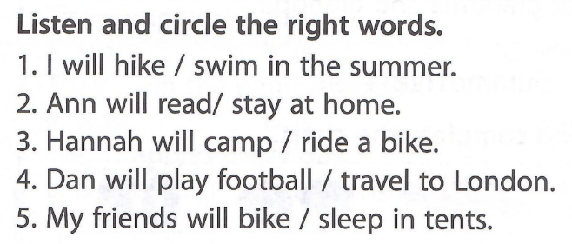

English: level A1.1: competence-based tests (p. 53)

Annex 2
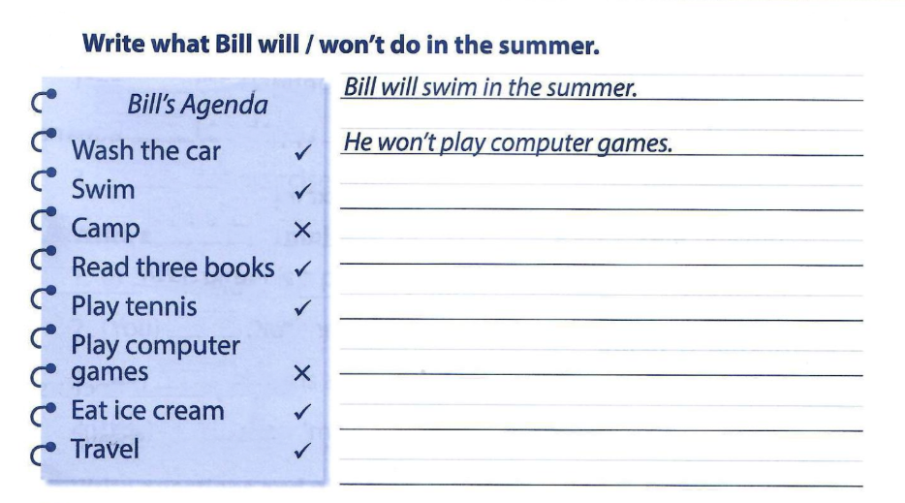

Workbook: Ex. 4 p. 69

