Lesson plan
Grade: II
Level: A1.1
Topic: HE’LL BE ELEVEN IN JUNE
Unit IV, Lesson 9 (2nd hour)
Specific Competences: SC1, SC2, SC3
Competence Units: 1.4, 1.7, 1.9, 2.3, 3.2, 3.3
Type of the lesson: Developing Knowledge Acquisition Abilities
At the end of the lesson, students will be able to:
O₁: identify and use new vocabulary related to personal belongings;
O₂: read a short dialogue and demonstrate its comprehension by identifying key information;
O₃: ask and answer questions using the structure: “Will you take a…?”
O₄: use the Future Simple tense in guided oral exchanges

Stages  (of the didactic activity) | Objectives | Activities | Time | Techniques  (methods/ forms of activities/ sources)
Evocation | O₄ | The teacher greets the students and introduces a simple rhyme:  - What will you do tomorrow? What will you do?  The teacher shows a picture. Students look at it and respond in chorus:  - I will read, I will read, I will read a book!  The teacher continues with different pictures. (see Annex 1)  Checking homework  A few volunteers are invited to read their sentences aloud to the class. | 5 min  4 min | TPR  Choral repetition  Oral feedback
Realization of meaning | O₁  O₂  O₃  O₄ | The teacher recalls the sentence from Tina’s mother: “We will be in the village tomorrow.” This leads into a short discussion about visiting relatives. The teacher introduces the new words: visit, take, and asks:  - What do you take when you visit your grandparents?  Students are encouraged to answer using familiar vocabulary. The teacher supports them by showing pictures on the screen (e.g., book, puzzle, tablet, etc.)  Next, the teacher moves on to the topic of personal hygiene and introduces more new vocabulary: slippers, towel, toothpaste, toothbrush, comb.  Students look at the picture and complete the sentences with appropriate words – Ex. 2 p. 84. (version 2)  Reading  The teacher assigns roles to students and asks them to read the speech bubbles aloud from the dialogue (Ex. 6 p. 85). The rest of the class listens attentively and follows along in their books. (*The teacher may pause and assist with pronunciation if needed.)  Post-reading  Students identify True and False statements (Ex. 7 p. 85). The teacher encourages them to correct the false ones using full sentences.  Speaking  The teacher pairs the students and gives each pair a set of picture cards showing different objects. Then, the teacher models the question:  - Will you take a … ?  Students take turns picking a card from the pile and asking their partner.  As they go, they sort the cards into 2 piles: one for yes answers and one for no. When all cards have been used, each student takes the yes pile and reports to the class about their partner:  - He will take a towel, slippers, and a comb. | 4 min  2 min  5 min  4 min  3 min  6 min  7 min | Contextualized vocabulary  Visual support  Matching / Gap-filling  Role-play reading  Listening for details  True-False  Whole class  Question & Answer  Speaking with visual support  Pair work  Reporting
Reflection | O₄ | “Snowball” game  Students work in groups of 6-7 to play a memory and speaking game.  - I will go to the village tomorrow and I will take a … | 5 min | Memory chain  Group work
Extension |  | Homework assignment:  “Packing for a Trip” – students receive a suitcase template. They “pack” it with things they would take on a trip.  Students should:  - draw 5-6 items inside the suitcase  - label each item in English (or full sentences, depending on level)  * Encourage the students to use both new words from the lesson and other familiar vocabulary (e.g., clothes, toys)

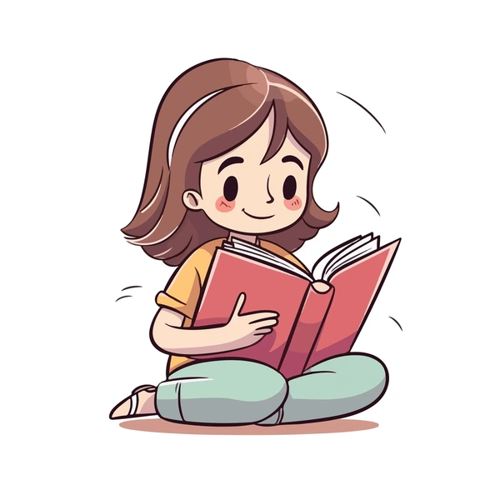
Annex 1
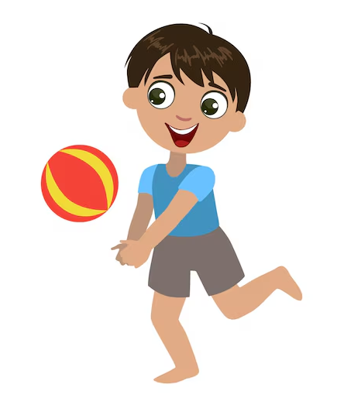
What will you do tomorrow? What will you do?
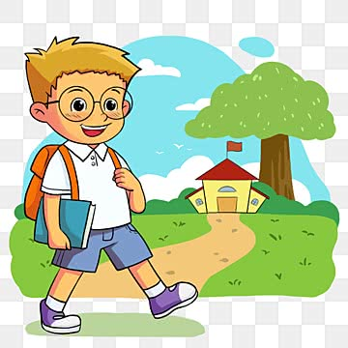
I will read, I will read, I will read a book!
…
I will go, I will go, I will go to school!
…
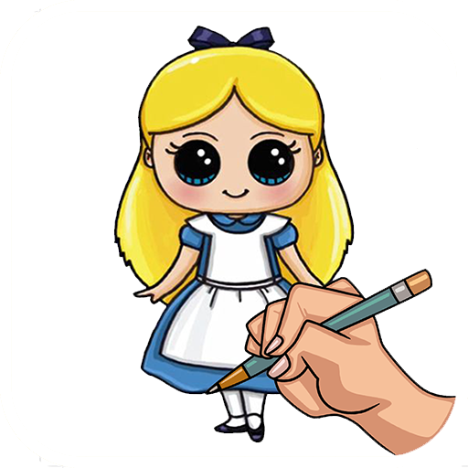
I will play, I will play, I will play a ball!
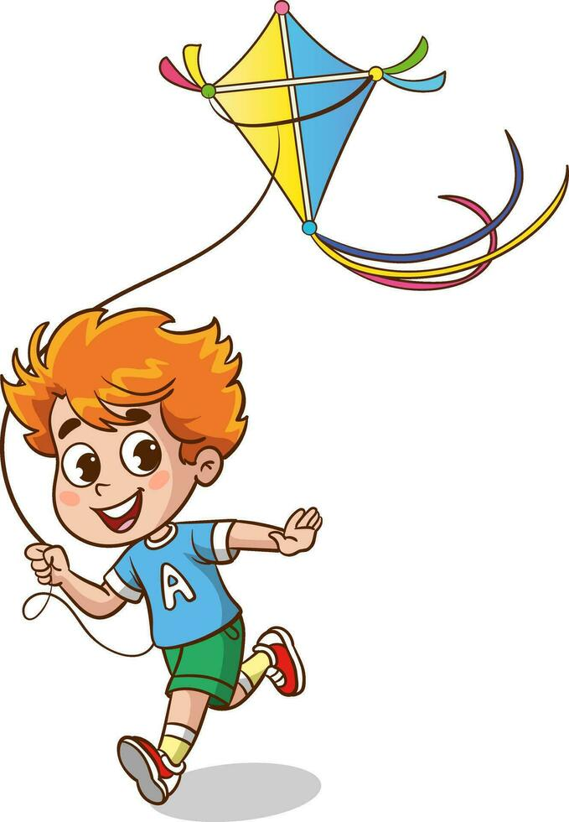
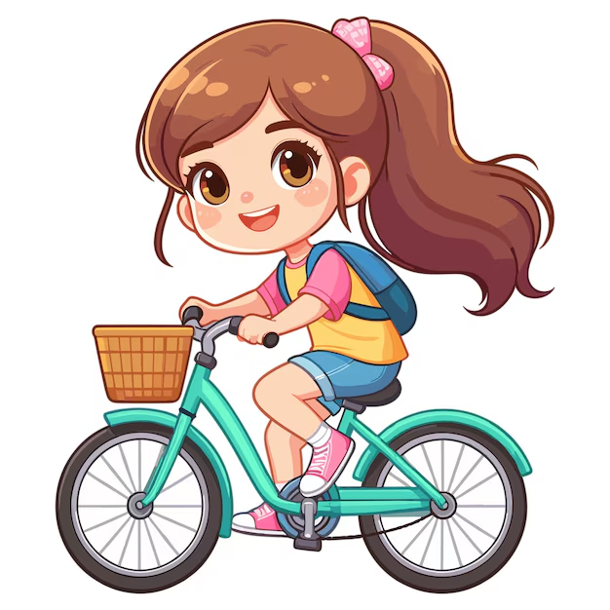
…
I will draw, I will draw, I will draw a doll!
…
I will ride, I will ride, I will ride a bike!
…
I will fly, I will fly, I will fly a kite!
…
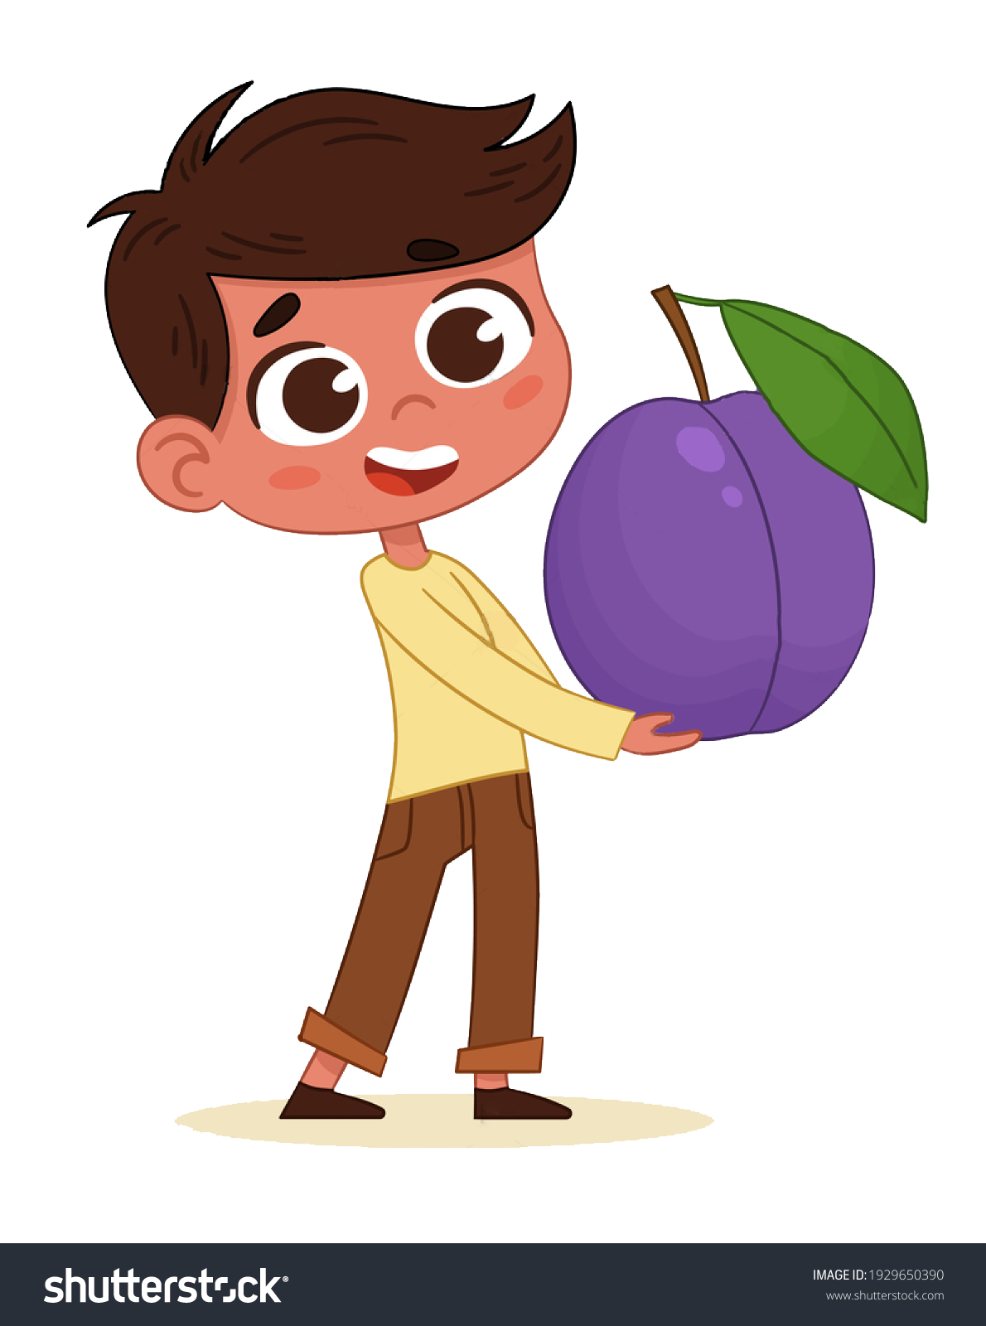
I will eat, I will eat, I will eat a plum!
…
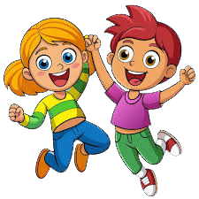
I will have, I will have, I will have fun!

Alternatively, students can perform the following actions: have fun, write, listen (to music), swim, eat (an ice cream).
As they act out each verb, the teacher writes the words on the board in a vertical list – one below the other.
At the end, the third letter of each word will spell the word VISIT.
🎯 This activity serves both as a physical warm-up and a fun vocabulary clue related to the lesson theme.

H | A | V | E |  | F | U | N
W | R | I | T | E
L | I | S | T | E | N
S | W | I | M
E | A | T

